Intel® Teach Program
Thinking with Technology Course

Foster Critical Thinking and Collaboration Skills, with free Professional Development for K-12 Teachers

Look at ways to use the Internet in new and constructive ways with your students.

You’ll leave with a standards-based unit plan, support materials, and implementation strategies to improve and assess students' higher-order thinking with the use of free, online tools.

You’ll use one of three thinking tools from Intel Education, teacher productivity tools, and Web 2.0 technology.

Learn more at www.intel.com/education/teach/us

Free online thinking tools at www.intel.com/education

Visual Ranking Tool: Identify and refine criteria for assigning ranking to a list; and then debate differences, reach consensus, and organize ideas.
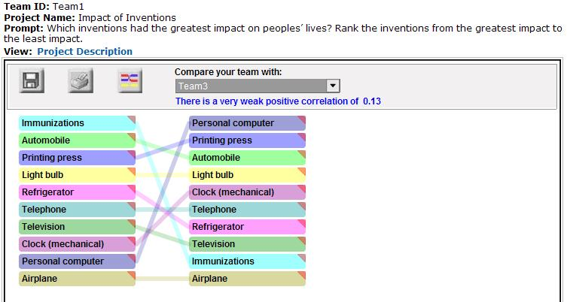

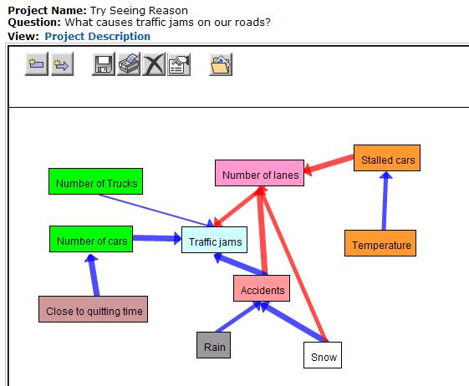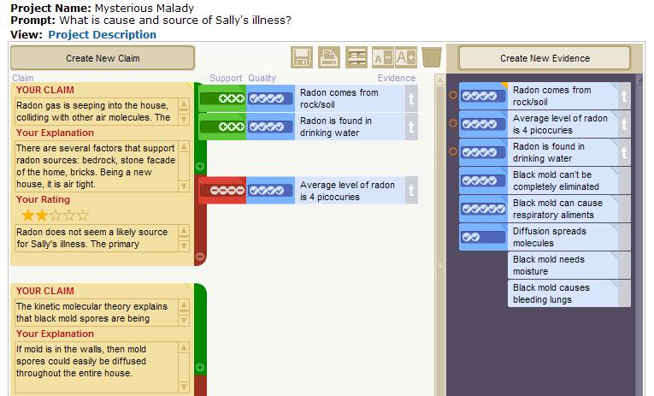
Showing Evidence Tool:
Construct well-reasoned arguments that are supported by evidence, using a visual framework.
Seeing Reason Tool: Investigate relationships in complex systems, creating maps that communicate understanding.
Thinking with Technology Course for (M or P) Teachers

Date:
Time:
Location:
Agenda: Visual Ranking, Seeing Reason, Showing Evidence (ADD hours)

For more information, contact:
Name | Phone | email address

